**VeriFone USB Driver Installation Guide**

June 6, 2013



Table Of Content

1 Introduction 3

2 Types of Installation 3

2.1 USB Driver Installation 3

o Standard Installation 3

o Using Installer 3

o Manual Installation 3

2.2 USB Driver Un-Installation 3

3 Standard Installation 3

3.1 Steps for Installation 3

3.2 Steps for Un-installation 4

4 Advanced Installation 4

4.1 Installation Using Installer 4

4.2 Manual Installation using device manager 5

5 USB Driver Un-installation 7

5.1 Normal Un-installation 7

6 Clean-up previously installed driver: 8

7 Disabling Auto-update Option on WIN 7 11

8 Toggle Zero Writes 13

9 Com Port Properties 13

10 Configuring USB Driver 14

11 Summary of command line options 14

# Introduction

This document details the procedure to install and uninstall VeriFone USB Driver. It covers both standard installation and installation for the advanced users. This VeriFone USB Driver installation supports Vx terminals on WIN 7 and WIN XP platforms.

# Types of Installation

The following section describes the different type of installations.

## USB Driver Installation

### Standard Installation

### Using Installer

### Manual Installation

## USB Driver Un-Installation

# Standard Installation

This section describes the standard installation procedure of USB driver.

## Steps for Installation

1. Use the clean up utility to cleanup all the previous VFI USB Driver residue if any.
2. Go to system administrator mode/user with administrator privileges in PC.
3. Right click on the **CleanUpUtility.bat**.
4. Click on “Run as Administrator”.
5. Download the zip file that is provided.
6. Extract the contents of the zip file to c:\usbdriver.  Create a folder **usbdriver**, if does not exists.
7. Open a command prompt.
8. Switch to c:\usbdriver directory.
9. Ensure that the device is unplugged from the PC.
10. Run the batch file according to the OS installed in the system.

**silent-xp-inst.bat** : This installs driver for Windows XP 32 bit and 64 bit OS.

**silent-w7-inst.bat** : This installs driver for Windows 7 32 bit and 64 bit OS.

**silent-we-inst.bat :** This installs driver for Windows POS Ready2009 OS.

|  |  |
| --- | --- |
|  | The user can provide the required installation mode as a parameter inside each batch file.  Installation modes parameters(not case sensitive) are,  **/I** for “Install mode”  **/P** or no parameter for “Preinstall mode”.  If the installation mode is not mentioned then the installation takes the default mode as “Preinstall mode”. |

|  |  |
| --- | --- |
|  | The user can provide the required COM port as a parameter inside each batch file. In the installation batch file provided the default port is mentioned is COM9. |

1. The driver will be installed without any UI.   Wait for the installation to complete.
2. Connect the terminal/PINpad using USB and power up the terminal.

## Steps for Un-installation

Method1:

1. Exit all the application that is using COM port.
2. Open a command prompt.
3. Switch to **C:\Program Files\VERIFONE\USB Driver** directory.
4. Run   
   **C:\Program Files\VERIFONE\USB Driver\unins000.exe /silent**.

Method2:

* 1. Go to path **C:\Program Files\VERIFONE\USB Driver**
  2. Double click on **unins000.exe**

**Note**:

Use the clean up utility to cleanup all the previous VFI USB Driver residue if any.

1. Go to system administrator mode/user with administrator privileges in PC.
2. Right click on the **CleanUpUtility.bat**.
3. Click on “Run as Administrator”.

# Advanced Installation

This section describes the installation procedure for advanced options.

## Installation Using Installer

1. Run the setup.exe and follow the instructions to install the driver.
2. While installing the driver, place the driver files to the default installation folder, “**C:\Program Files\VERIFONE\USB Driver**”.

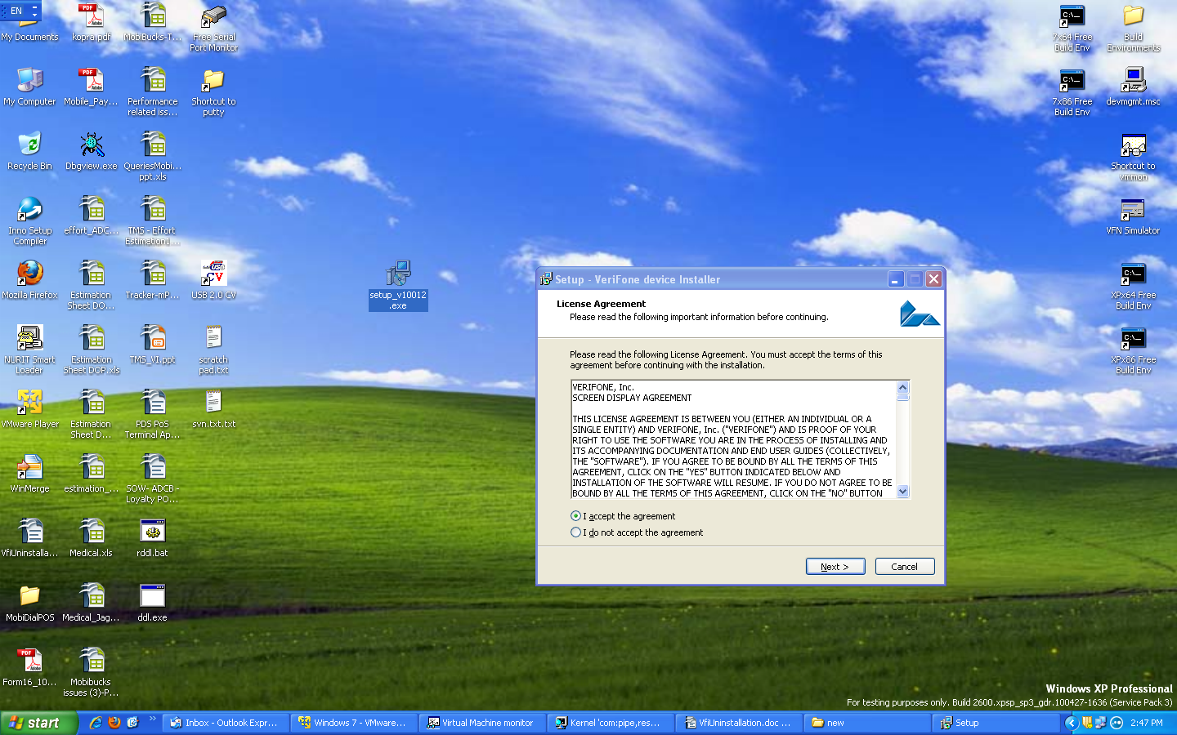

## Manual Installation using device manager

1. Connect the device to the PC, ensure the device is listed in the device manager: It will be shown as a new USB device with yellow exclamation mark.
2. Right click the device and select **update driver** option, select install from specific location (advanced) option
3. Select **Don't search. I will choose to the driver to install** option.

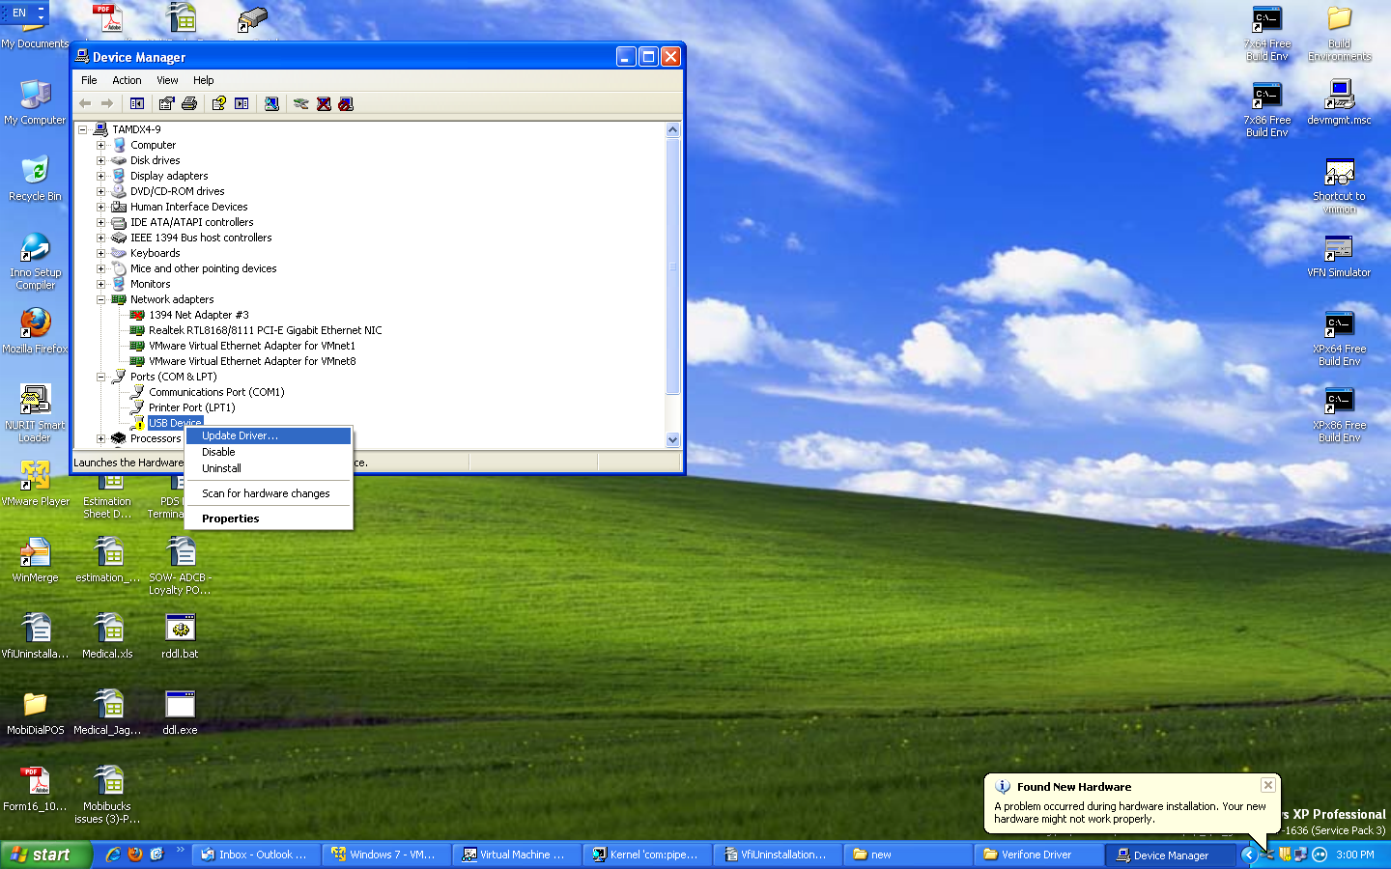

1. Select **Have a disk** option and provide the extracted folder path (ex. **C:\Program Files\VERIFONE\USB Driver.**

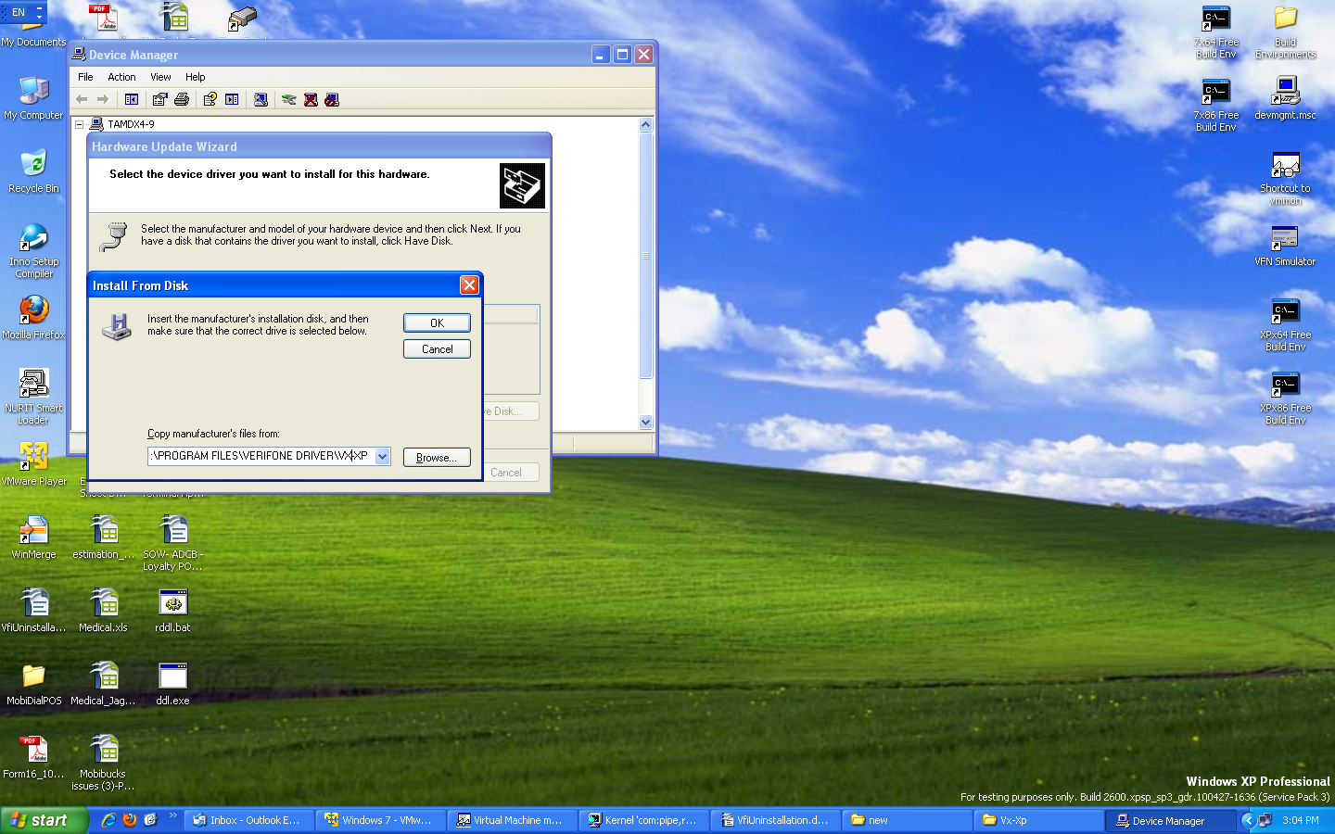

1. Click **OK** to proceed and complete the manual installation.

|  |  |
| --- | --- |
|  | * Vx-7 directory is selected if the PC used is Windows 7, 64/32 bit and the device is Vx. |

# USB Driver Un-installation

## Normal Un-installation

1. Select the option sequence Start → Control Panel → Add or Remove Programs and Double click **VeriFone device Installer Ver. X.X.X.X.**

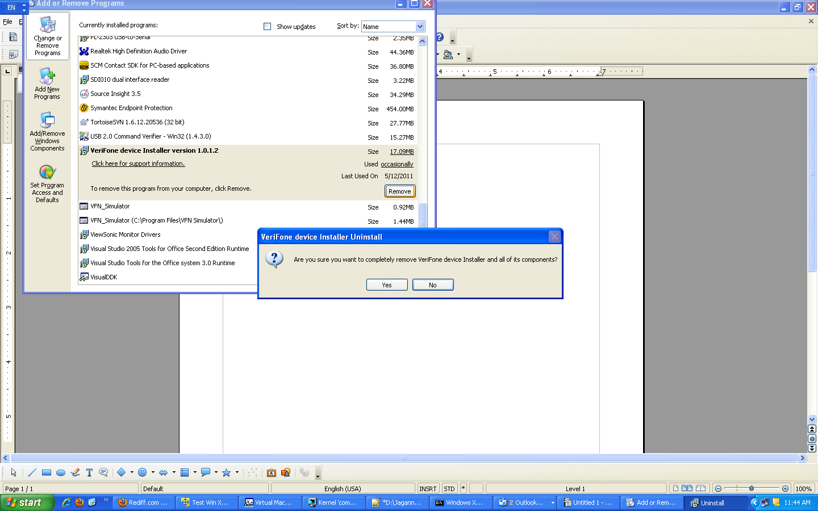

# Clean-up previously installed driver:

This section describes the procedure to clean up the previously installed driver before initiating the new installation of USB driver.

|  |  |
| --- | --- |
|  | It is recommended to follow the installation procedure explained in the above sections. Follow this Clean-up procedure only if the installation procedure mentioned in the above section fails. |

1. Repeat the un-installation procedure mention in the section **5.1, Normal Un-Installation.**
2. Go to **C:\WINDOWS\inf** directory
   1. Press F3 (to invoke search option, choose search companion).
   2. Enter details: Enter “*.inf” in the file-name box, “VeriFone” in the word/phrase box (without quotes).
   3. Search will provide the name of the inf file (Example: oem32.inf)
3. Delete the found inf file and corresponding pnf files (Example: oem32.inf & Example: oem32.pnf).

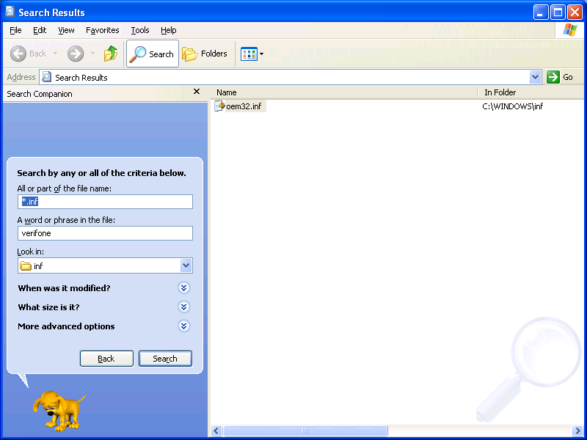

1. Before performing above step note down the corresponding .sys file present in the .inf file as shown below.
2. 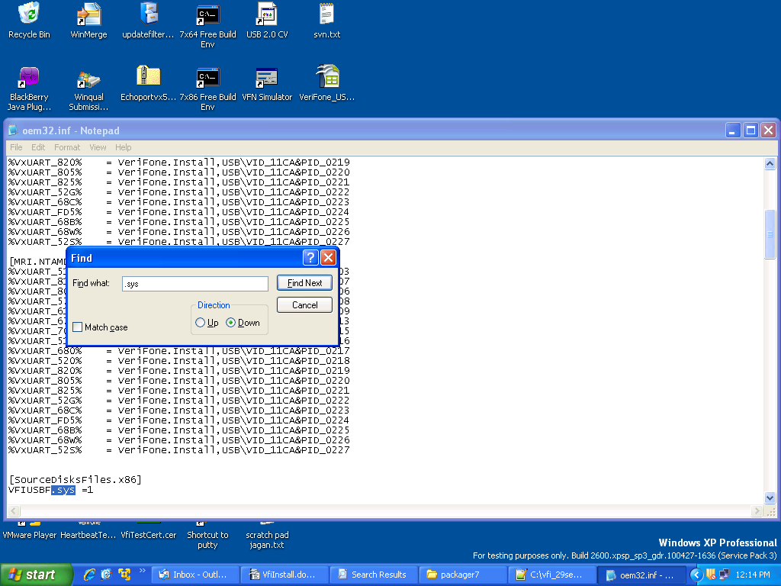Go to “C:\WINDOWS\system32\drivers” → delete the .sys file (Ex: VFIUSBF.sys & VfiEnum.sys).
3. Also check DRVSTORE dir (C:\WINDOWS\system32\DRVSTORE) for any folder which has the same .sys and inf file → If present delete the folder.

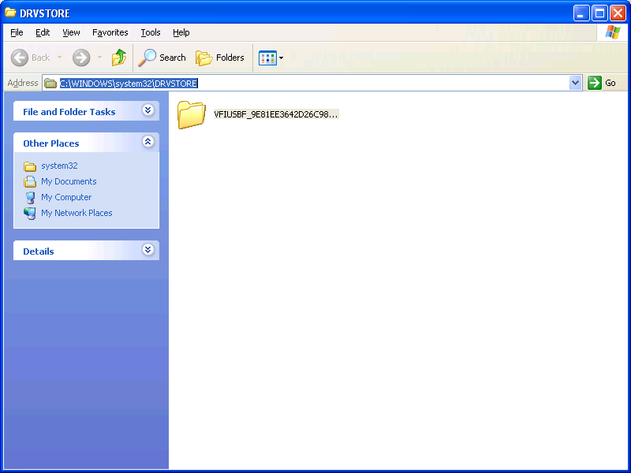

# Disabling Auto-update Option on WIN 7

To disable the option to download the drivers, select devices and printers from the start menu. Select the device with your computer name and right click, the context menu is displayed as shown below.

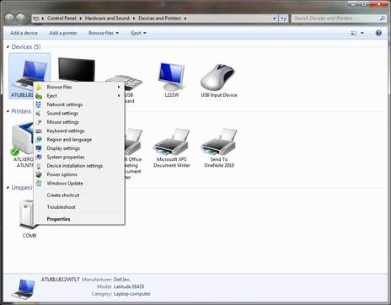

Select **device installation settings** option from the context menu. In the device installation settings window, select **No, let me choose what to do** option and then select **Never install driver software from Windows Update** option.

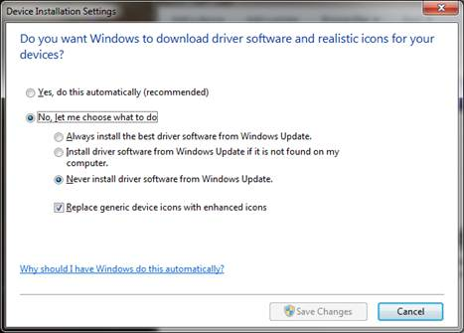

# Toggle Zero Writes

On some of the java applications that uses javax.comm package, which handles output data fragmentation before sending to driver, disabling the zero length writes are required.

The following steps are provided to explain the enabling and disabling the zero length writes( default behavior is enable)

* 1. Close all the applications using Vfi com port, disconnect the devices.
  2. Open command prompt(On windows 7,open the prompt with Admin privileges)
  3. Go To installed directory in C:\Program Files\VeriFone\USB Driver.
  4. Run “VfiUsbNoZeroWrite.exe 0” <-- set for zero writes OR Run “VfiUsbNoZeroWrite.exe 1” <-- disables zero writes
  5. Restore the device connections and start the applications.

# Com Port Properties

* 1. By default Windows allows usage of com port numbers up-to 255.
  2. V19 driver also supports com ports assignment up-to 255. Using default setup, com9 will be assigned, however user can choose to change the comport using SetVfiPort.exe utility from the command prompt.

Ex: Existing driver installed to use com port from com9 onwards.

However if one wants to use com ports starting from com 20:

* + Disconnect the device.
  + Invoke command prompt (in windows 7, invoke command prompt with admin privileges) go-to driver installed directory (C:\Program Files\VeriFone\USB Driver)
  + cd C:\Program Files\VeriFone\USB Driver
  + Execute the command “**setvfiport 20**” to assign from com 20.
  + Re-connect the device.

During certain scenarios like accidental power cutoff, comports resource will not be released by the driver, when power returns back, PC assigns next com-port to the device (ex: com9 is assigned before power-off and com10 after). In-order to regain the com9, user can perform below steps:

* + Disconnect the device
  + Invoke command prompt (in windows 7, invoke command prompt with admin privileges) go-to driver installed directory (C:\Program Files\Verifone\USB Driver)
  + cd C:\Program Files\Verifone\USB Driver
  + Execute the command “**ComReset.exe 9**”.
  + Re-connect the device.

# Configuring USB Driver

The installer has registry entries set for all normal operations. It is recommended not to change any of the values set by installer.

However, if you face any issues after installation, refer to following registry entries that might help to make USB work.

Registry entries related to USB driver can be found in the following location.

[HKEY_LOCAL_MACHINE\SYSTEM\CurrentControlSet\Control\VeriFoneUSB]

VfiUsbNoZeroWrite = 1

Java application is not allowing zero length writes for multiples of end-point size (ex. 512 = 8 x 64 bytes and USB EP=64 bytes). As it itself is performing fragmentation of the data. Applications using javax.comm need to set this 1.

VfiCustomRead = 1

Legacy applications using mscomm32.ocx library needs to set this to 1.

# Summary of command line options

|  |  |  |
| --- | --- | --- |
| **Command line Option** | **Registry Entry** | **Description** |
| /nonlegacy | VfiCustomRead = 0 | For all the applications |
|  | VfiCustomRead = 1 | For Legacy applications (built using VB & mscomm32.ocx) which accesses com port |
| /multidev | VfiMultiDevice = 1 | Enable connecting multiple devices to same PC |
|  | VfiMultiDevice = 0 | Disable connecting multiple devices to same PC |
| /NOZEROWRITE | VfiUsbNoZeroWrite = 1 | For Java applications which uses javax* library and perform write data fragmentation at the application level. |
|  | VfiUsbNoZeroWrite = 0 | For All other applications |

Notes:

* + 1. The highlighted rows are default when silent.bat is used.

<EOD>